Assembly Language Report (Week 2)

Group 7

104502517戴逸任

104502518劉冠聲

Program CODE:

.code

main PROC

mov al,10010b ;last two digits of leader’s students ID in binary

mov ah,17 ;last two digits of member’s students ID in decimal

mov ax,2518h ;last four digits of student’s ID in hexadecimal

mov dx,0EEEAh ;let the value of dx is eeea

sub dx,ax ;value of dx subtracting by ax

main ENDP

END main

Program Step & Register state:

mov al,10010b ; ah=0x33 al=0x12 ax=0x3312 dx=0x1005

mov ah,17 ; ah=0x11 al=0x12 ax=0x1112 dx=0x1005

mov ax,2518h ; ah=0x25 al=0x18 ax=0x2518 dx=0x1005

mov dx,0EEEAh ; ah=0x25 al=0x18 ax=0x2518 dx=0xeeea

sub dx,ax ; ah=0x25 al=0x18 ax=0x2518 dx=0xc9d2

Picture & Discription:

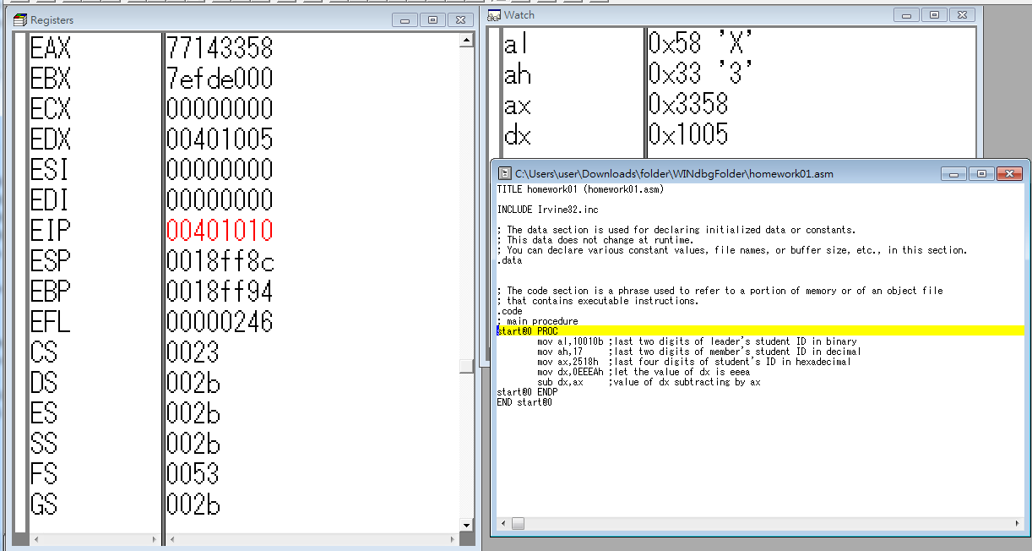

Step1: Start the program

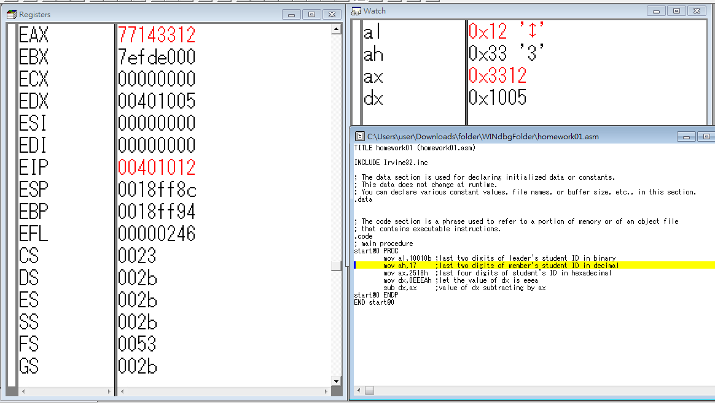

Step2: mov al,10010b ;store the value 10010(binary) into the register al

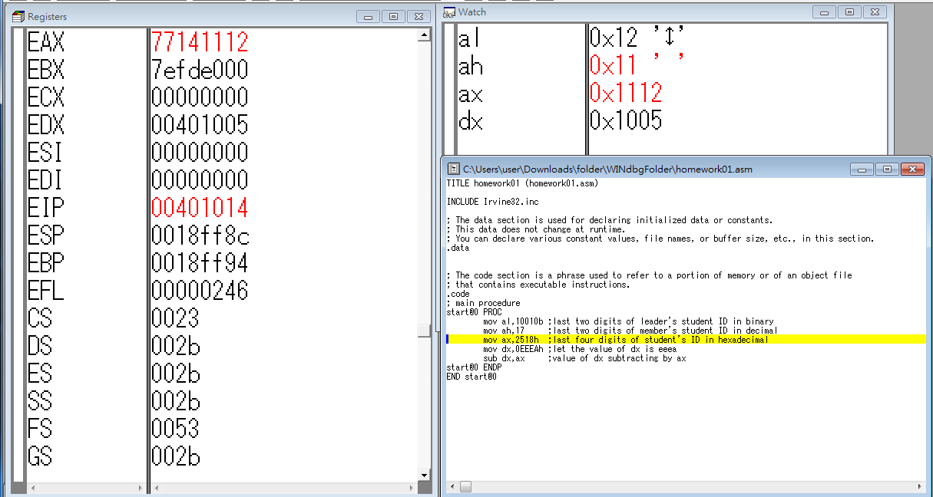

Step3: mov ah,17 ;store the value 17(decimal) into the register ah

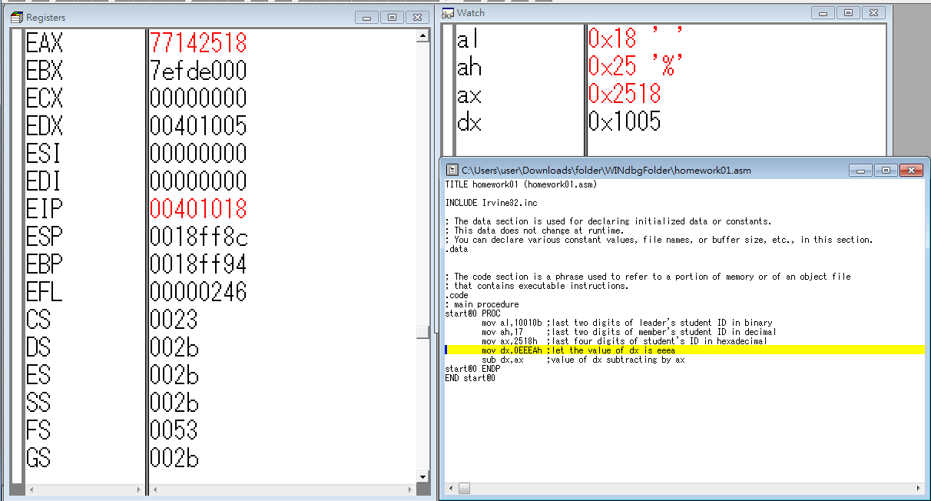

Step4: mov ax,2518h ;store the value 2518(hexadecimal)into the register ax it means that 0x18 in the register al and 0x25 in the register ah

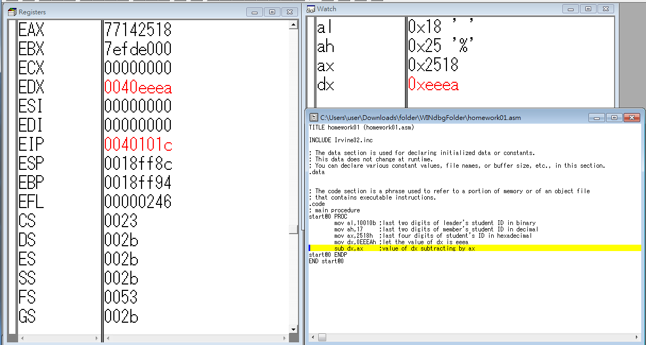

Step5: mov dx,0EEEAh ;store the value 0EEEA(hexadecimal)into the register dx

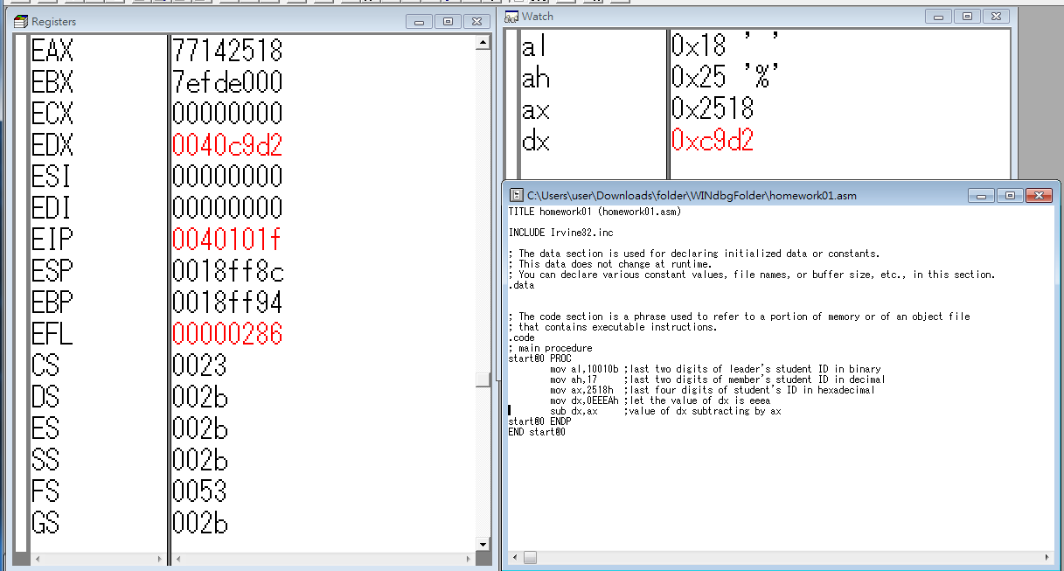

Step6: sub dx,ax ;calculate the value in dx subtracting by the value in ax and then store into the register dx (dx=dx-ax)

Review:

In the beginning, we can't clearly know what TA want us to do because our English ability are not pretty well, we transformed last four digits of our student’s ID into hexadecimal, after we run the windbg and finish the part of screenshot then know that we misunderstood the true meaning of the report, though we had to do the same act again, we also learned a lesson about being careful to do everything.

The assembly language is a middle level of programming language, it’s really different from the high level programming language which we used to use, such as JAVA and C++, but we can easily realize the assembly language code so far, so we thought that it is a good start to learn assembly language.